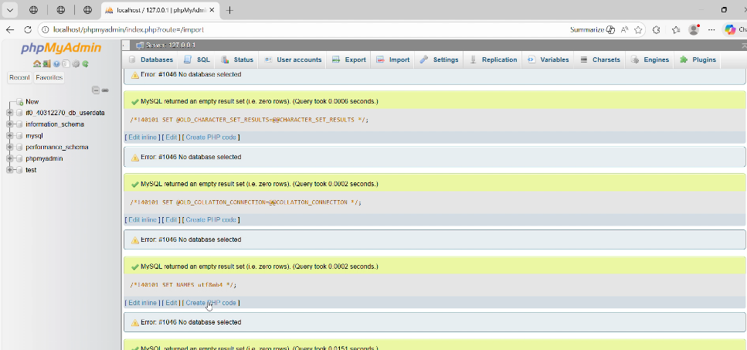
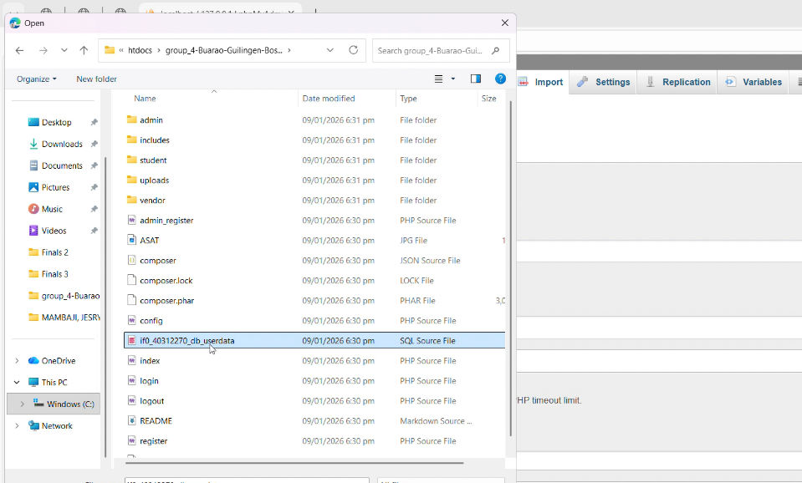
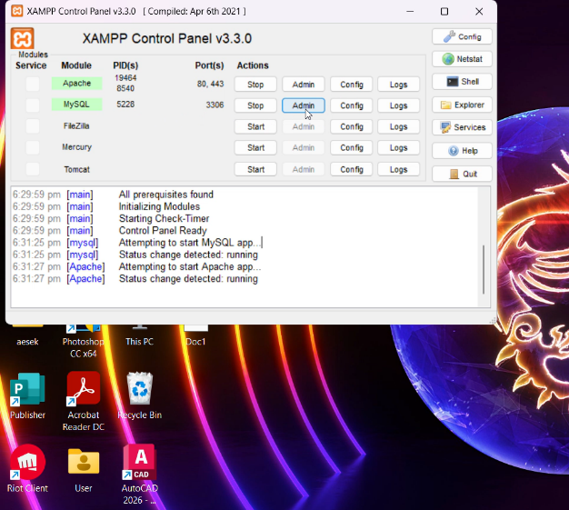
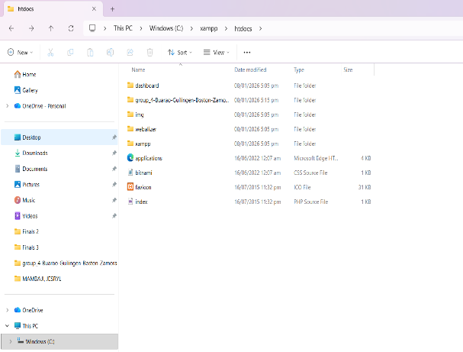
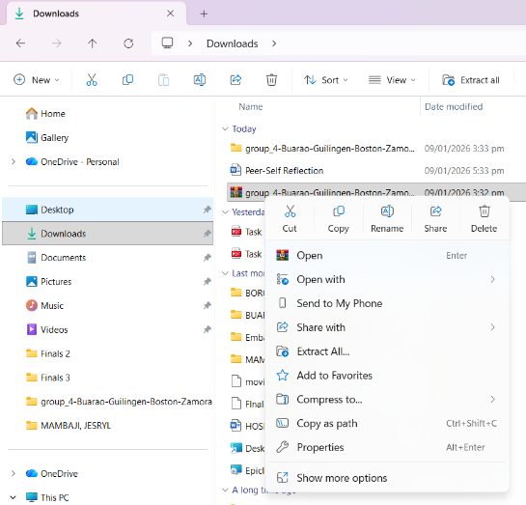
5. finish imported
4. import the database inside the folder C:\xampp\htdocs\group_4-Buarao-Guilingen-Boston- Zamora
3. run xampp and click admin
2. move your file to xampp
- C:\xampp\htdocs\group_4-Buarao-Guilingen-Boston- Zamora\index.php
- Extract the file.

7. in terminal type C:/xampp/php/php.exe -S 127.0.0.1:4435
6. in vscoce and open the project folder group_4-Buarao-Guilingen-Boston-Zamora

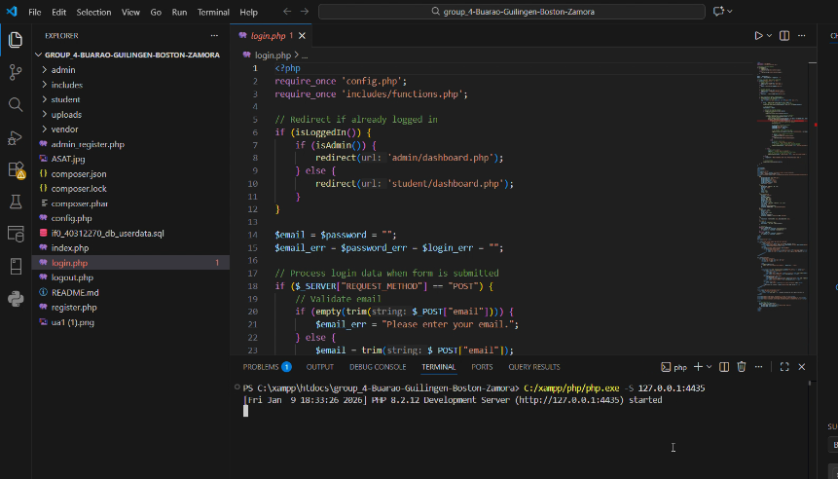
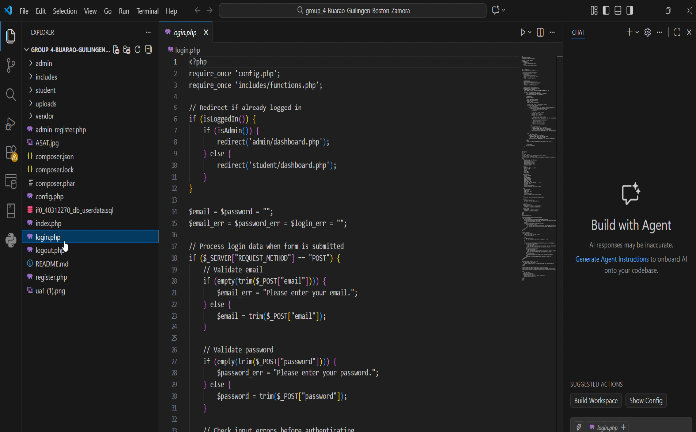

9. done
8. the click the http: when the follow link show up click it

